2) After user logs into the Admin main page he/she sees the page below:

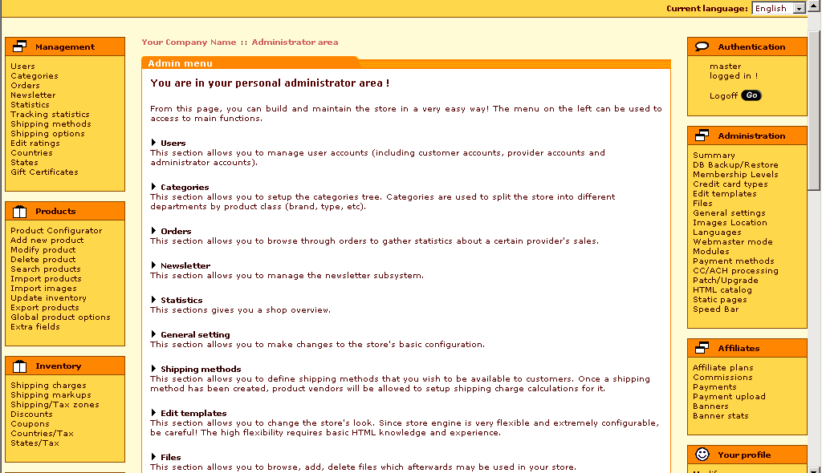
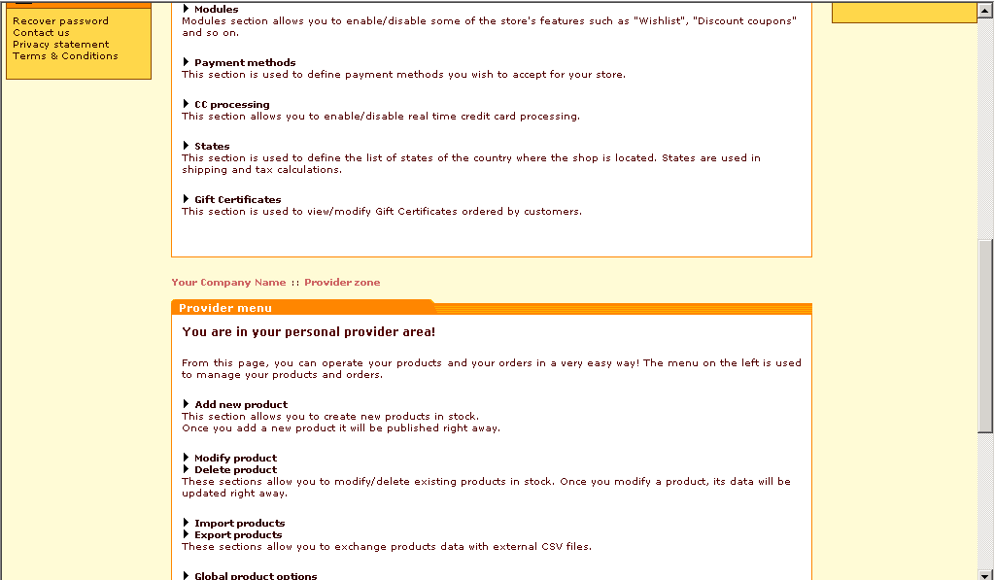
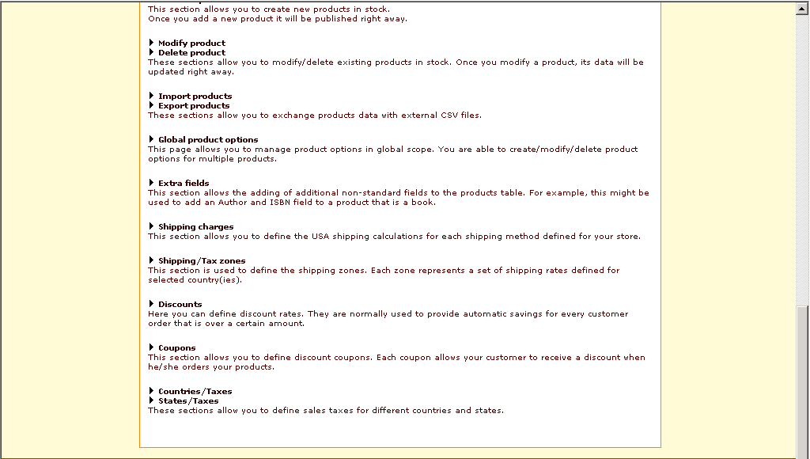

Management Section:

- 3) Users: This section allows you to manage user accounts (including customer accounts, provider accounts and administrator accounts).
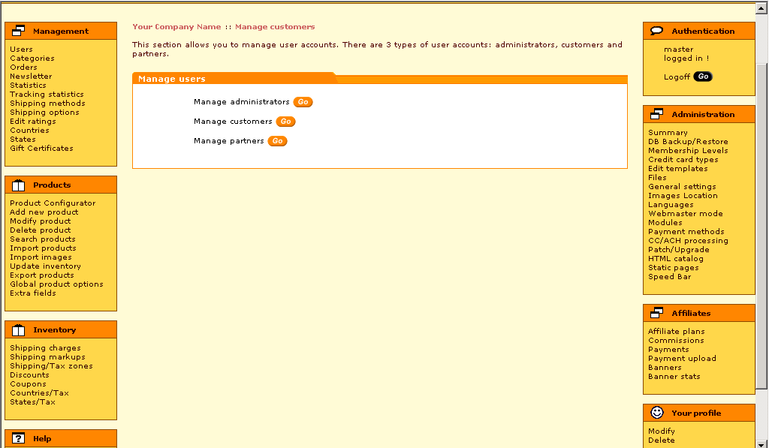

4) Categories: This section allows you to setup the categories tree. Categories are used to split the store into different departments by product class (brand, type, etc).
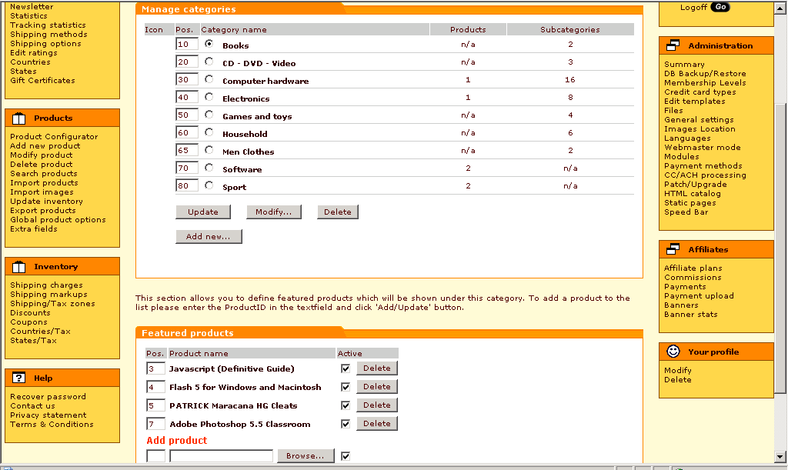

5) Orders: This section allows you to browse through orders to gather statistics about a certain provider's sales.
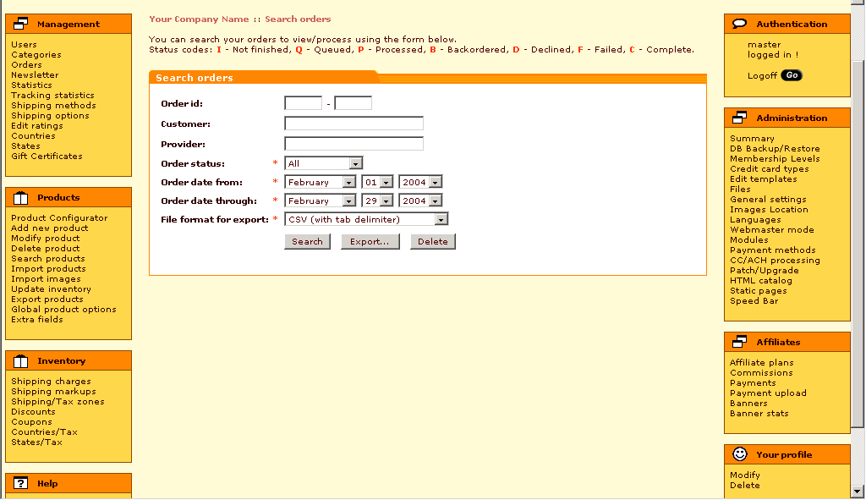

6) Newsletter: This section allows you to manage the newsletter subsystem.
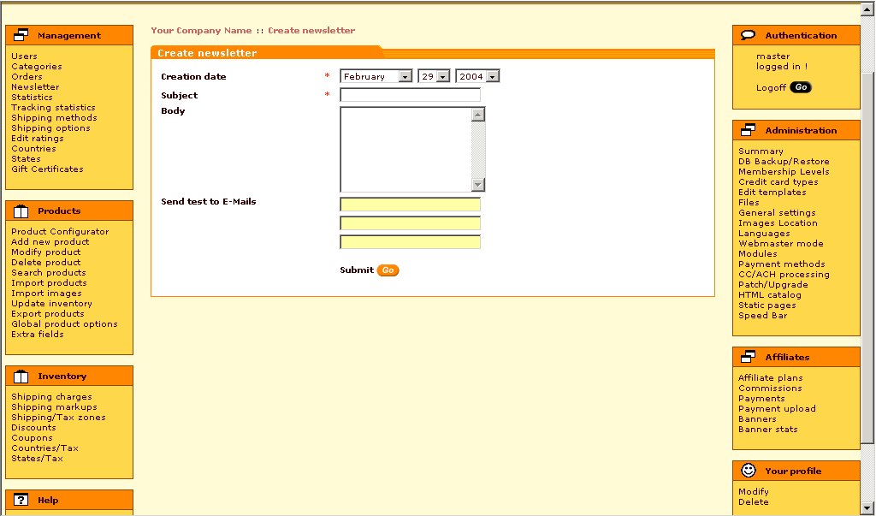

7) Statistics: This section gives you a shop overview.
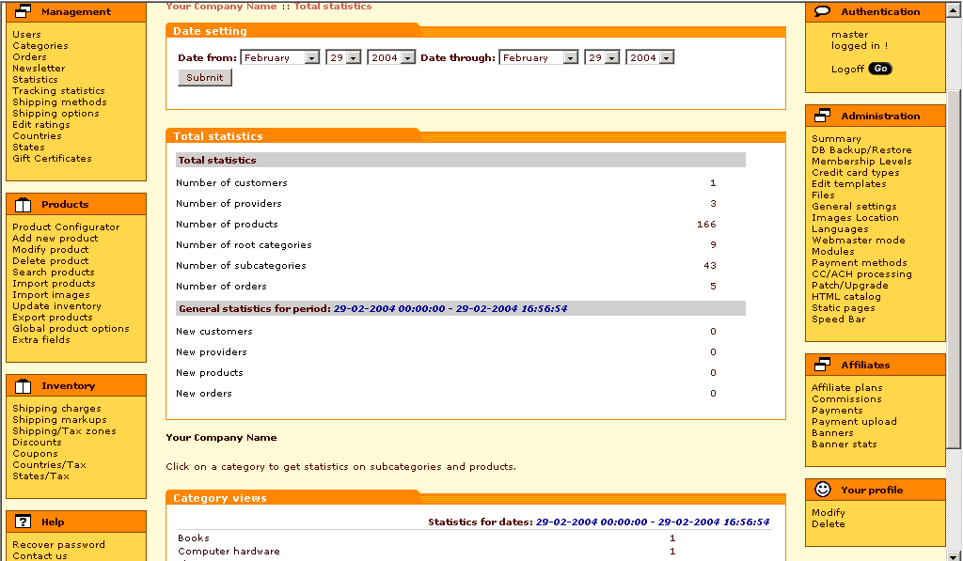

8) General Settings: This section allows you to make changes to the store's basic configuration.
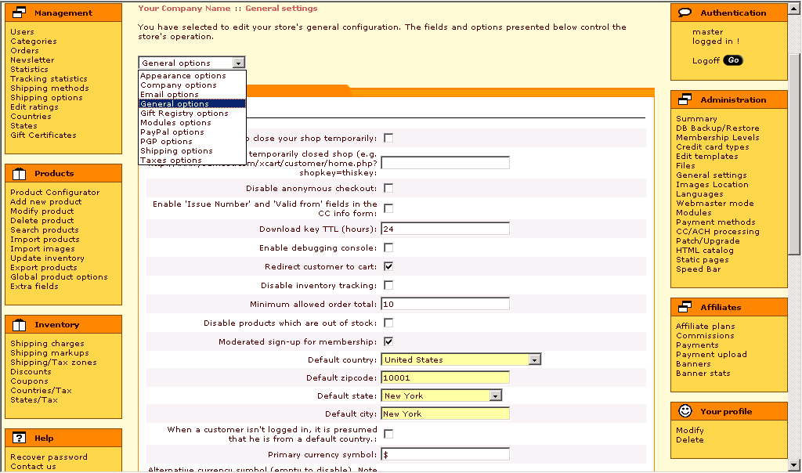

9) Shipping Methods: This section allows you to define shipping methods that you wish to be available to customers. Once a shipping method has been created, product vendors will be allowed to setup shipping charge calculations for it.
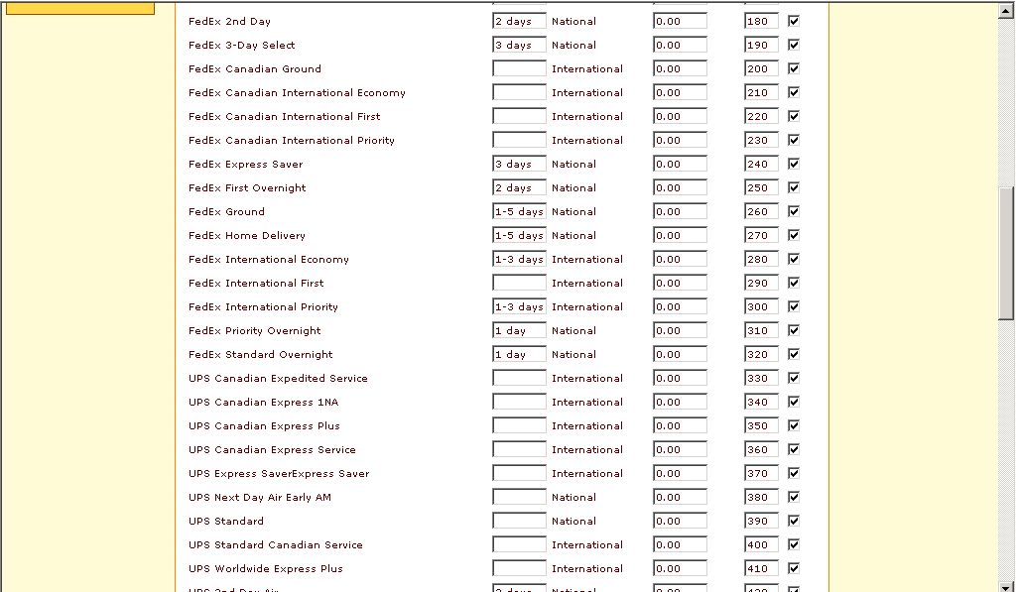

10) Edit Templates: This section allows you to change the store's look. Since store engine is very flexible and extremely configurable, be careful! The high flexibility requires basic HTML knowledge and experience.
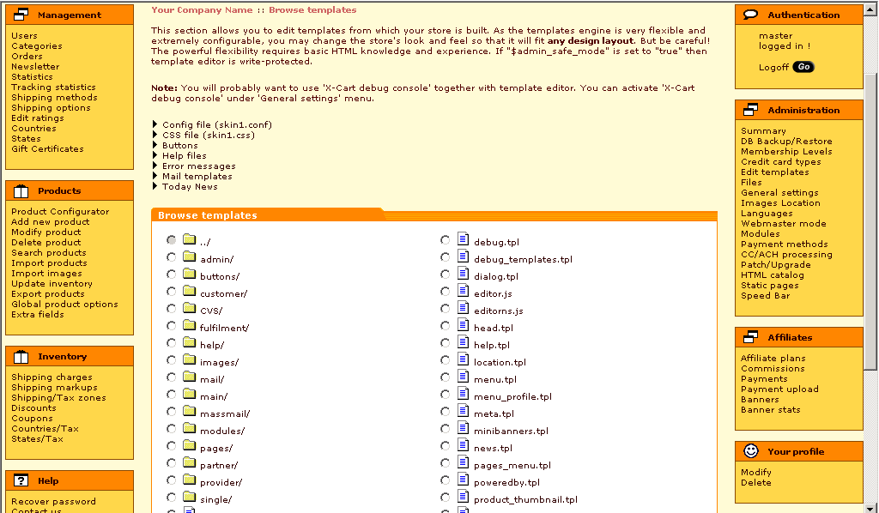

11) Modules: Modules section allows you to enable/disable some of the store's features such as "Wishlist", "Discount coupons" and so on.
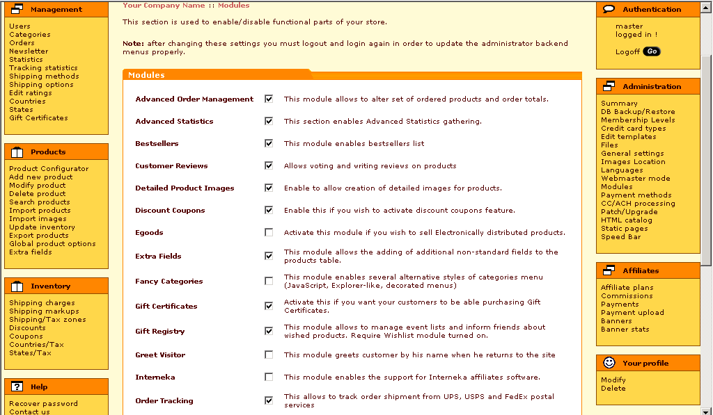

12) Payment methods: This section is used to define payment methods you wish to accept for your store.
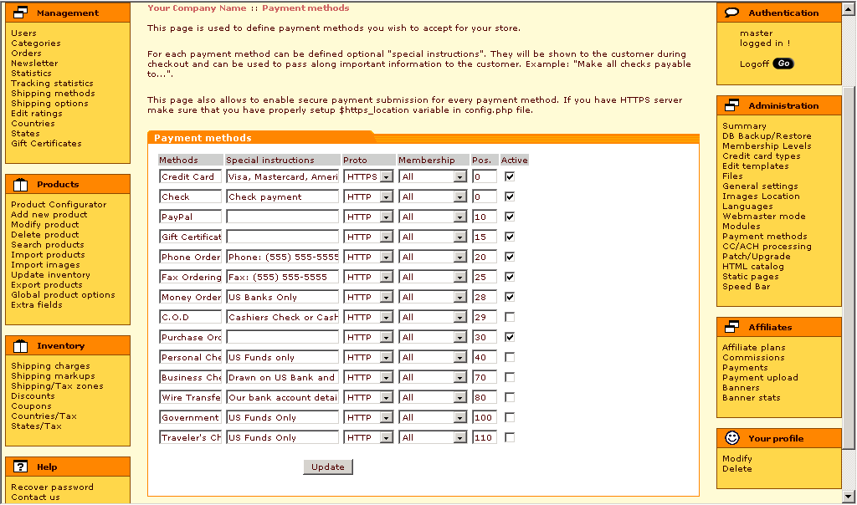

13) Gift Certificate: This section is used to view/modify Gift Certificates ordered by customers.
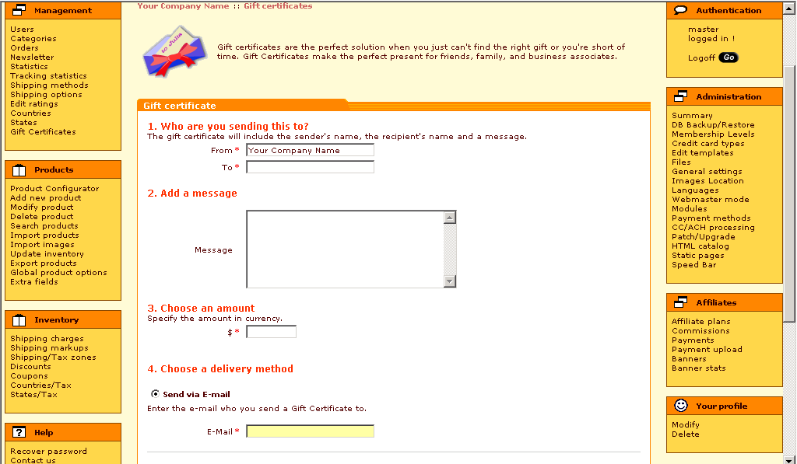

Products Section allows to create/modify/delete/import from other files product categories and items, their availability and attributes:

- Shipping Charges: This section allows you to define the USA shipping calculations for each shipping method defined for your store.
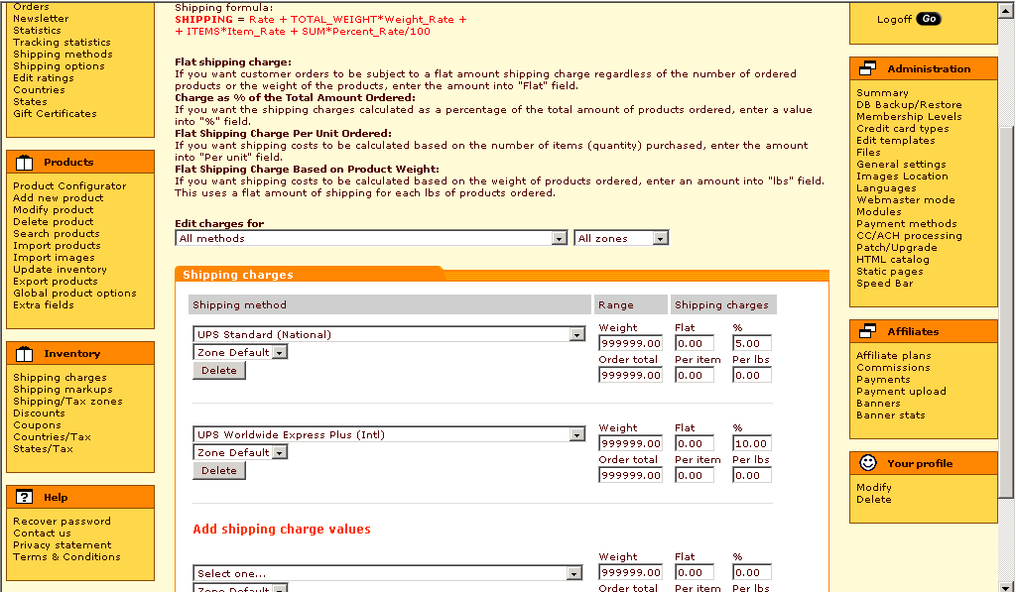

- Discounts: This page allows you to define purchase discounts you want to be active for your store. Purchase discounts apply to all customer orders and do not require the customer to enter any type of "code" to receive the discount. These are normally used to provide automatic savings for every customer order that is over a certain amount.

- Store Coupons: This page allows you to define coupons that you wish to accept for your store. Each coupon allows a customer to receive a discount when he/she orders products from your store.
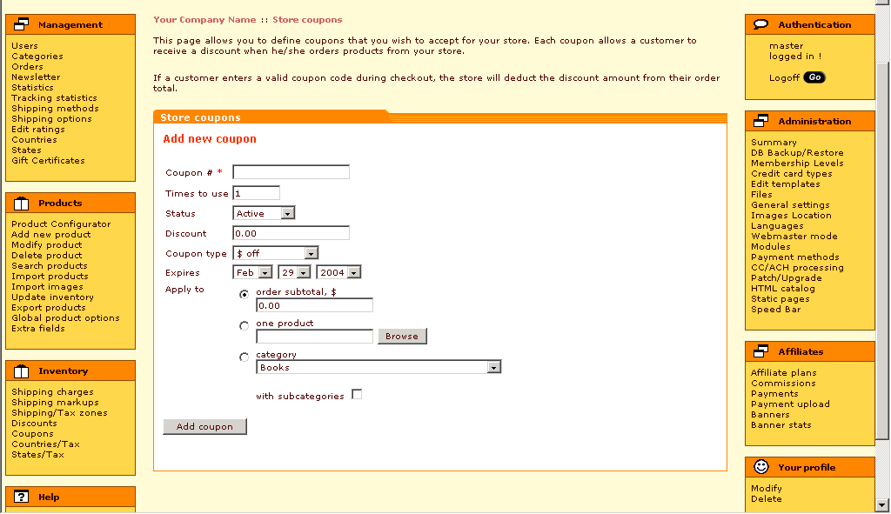

Complete Feature List.:

☺☺☺

